Nama : Aditia Surya Putra

Kelas : Flutter D

Souce Code

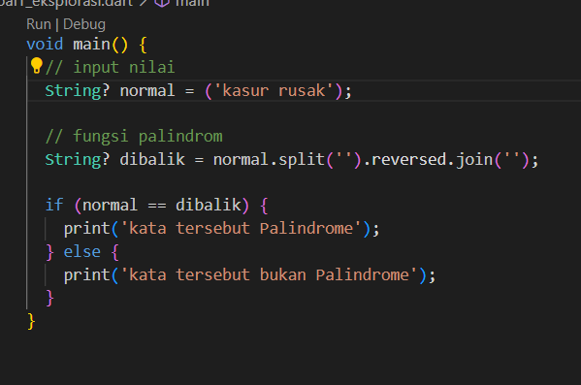

|  |  |
| --- | --- |
| Input | Output |
|  |  |
|  |  |